Name: Wang Zihao

Student number: A0204706M

Week 5 Studio 1

Group 4b

11th February 2020

Question 1: **The explanation is commented in the code.**

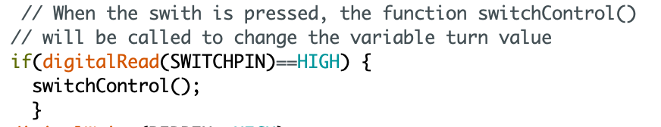

This if statement is inserted inside the loop of flashRed and flashGreen function to call the switchControl function to change the “turn” value .

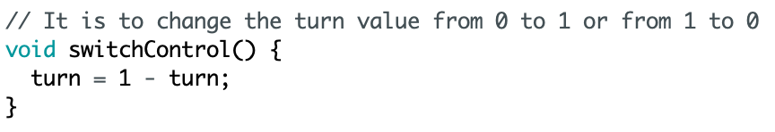

This function is to switch the turn value from 0 to 1 or from 1 to 0 such that when the switch is pressed, the state will change.

Question2:

2(a). The attachInterrupt function introduces Interrupts to the system and translates the actual digital pin to the specific interrupt number.

attachInterrupt(digitalPinToInterrupt(pin), ISR, mode)

**interrupt:** the number of the interrupt. Allowed data types: int.  
**pin:** the Arduino pin number.  
**ISR:** the ISR to call when the interrupt occurs; this function must take no parameters and return nothing. This function is sometimes referred to as an interrupt service routine.  
**mode:** defines when the interrupt should be triggered. Four constants are predefined as valid values: LOW is to trigger the interrupt whenever the pin is low, CHANGE is to trigger the interrupt whenever the pin changes value, RISING is to trigger the interrupt when the pin goes from low to high, FALLING is to trigger the interrupt when the pin goes from high to low.

2(b). When the switch is pressed, the digitalRead function will be directly called by the hardware when the interrupt pin changed as the result of attachInterrupt function. Hence, the controller will jump to ISR and change the value of onOff from 1 to 0 or from 0 to 1 when the trigger is pressed.

Question 3:

3(a).

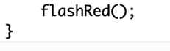



The attachInterrupt is used to introduce the interrupts to the system. When the switch is pressed, ISR(i.e. switchISR) would be called.

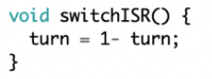

The ISR is called to change the value of turn from 1 to 0 or from 0 to 1 when the interrupts is introduced.

3(b). The interrupt version works better. For polling, the digitalRead is inside the for loop and will be run continuously which occupies the microcontroller and keeps the microcontroller busy-waiting, and when the timing is missed, the event would not be captured. However, the interrupts will free up the time for the microcontroller to do other tasks simultaneously and when the event is triggered, the controller will jump to ISR.

Question 4:

4(a).

This part is introduced to debounce the switch by introducing a delay to skip the unstable contact bounce time. When the contact bounce time is skipped, the flashGreen and flashRed functions will be called.

4(b). Yes. The optimum value is round 5ms for THRESHOLD.

4(c). If THRESHOLD value is too small, it will be shorter than the contact bounce period such that the debouncing fails to achieve its effectiveness. If THRESHOLD value is too large, the respond time of the switch is too long, which means we need to wait too long for the ISR is called after the event is triggered.

Question 5: **The explanation is commented in the code.**

